Category-GuestPost
Company-General Informative
Keyword-Repair damaged PST file after Outlook Profile get corrupted

Note: Keywords used are highlighted in green throughout the article.

Keywords:
repair damaged pst file, repair damaged outlook archive, outlook profile not loading, how to repair damaged pst file outlook 2013, corrupted pst file, repair a corrupt pst file, how to repair a damaged .pst file in outlook 2010, outlook 2010 keeps corrupting, repair damaged pst file outlook 2010 large, repair damaged pst file outlook 2010 password protected

How to Repair Damaged PST File after Outlook Profile Gets Corrupted
Many users work with Microsoft’s Outlook because it is a desktop based email application that provides good information management. Their emails, Calendar events, contacts and notes are all saved within one application. Outlook stores the user data in PST, and OST file format. PST or Personal Storage Table files contain a replica of the messages on Desktop, i.e. user data as saved on the hard disk.
Since Outlook works with Exchange Server to regularly sync the new emails and data, another file called the OST file is kept on the server. OST or Offline Storage Table files are a copy of the data stored on the Exchange server. But, sometimes users report their Outlook profile not loading. It could be because of a corrupted PST file. Users face a lot of problems because suddenly they cannot access their important email. Keep reading to find out how to repair damaged PST file after Outlook profile gets corrupted.

Reasons to Repair Corrupt Outlook File
When users configure an email in Outlook, a large amount of data is transferred to Outlook for a smooth offline experience. In time, this data starts to come close to the size limit. It may cause damage to an Outlook profile. The reasons of a PST file corruption could be any of the following:
- Slow Outlook performance due to a large amount of application data
- Send and receive failure

“When I started Outlook today, it did not open. It displayed the error message that it could not load the Outlook window. While it was working perfectly yesterday. I have tried to reopen the PST file from the source but seems to be corrupted. Now, I cannot open my emails, I have to urgently send work project that is in my Outlook. Does someone know how to repair a damaged .pst file in outlook 2010”

As seen above, an Outlook profile may get corrupt due to a system failure. But the user needs to access his emails because they contain all his important data and other details necessary for his work.

Methods to Repair a Corrupt PST file
Since any kind of Outlook failure hampers the whole work process, such problems should be quickly resolved.
Solution 1- The first method explains the manual steps of how to repair a damaged .pst file in outlook 2010.
- Manual Repair in Outlook 2010, 2013, 2016
They are also applicable to Outlook 2013, Outlook 2016, and Office 365.
Following are the methods of how to repair damaged PST file after Outlook profile gets corrupted:
- Open Control Panel>>Mail. The Mail Setup dialog box will open.
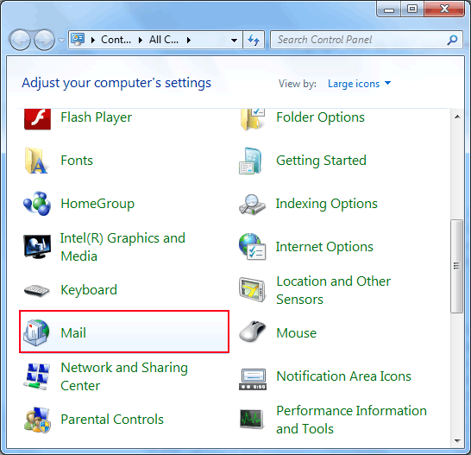

- In the third option, click Show Profiles.
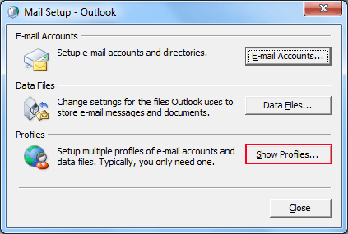

- In the new menu, choose the Outlook option, and click Remove. This will remove the old PST file saved on the computer.
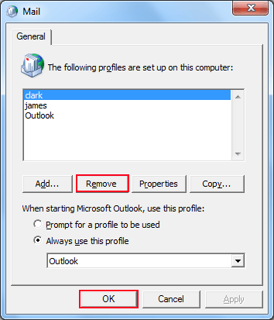

- In the same Window, click Add. This will create a new profile for Outlook on the computer.
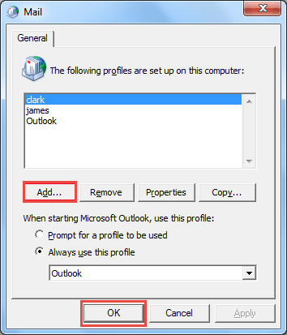

- Name the new profile, and click OK.
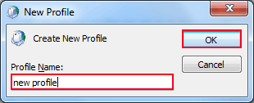

Now, start Outlook. Open it with the new profile just created. It should display the contents of the email address you entered.

- For Outlook 2007
The manual procedure for repair is through Outlook 2007 itself. The steps are as follows:
- Open Outlook 2007. Go to Tools>> Account Settings.

- Open the Email tab. Select your account (profile), and click on Repair.

- In the Recovery window, select all the necessary prompts. Restart Outlook when you are done.

Tip: It is recommended to take regular backups of data stored in Outlook. So that in the case of a sudden failure or file corruption, it is easy to restore that data to Outlook. It is a particularly good practice if the data saved on disk is of a large size.

Limitations of the Manual Method:
The manual method of trying to repair damaged outlook archive has the following limitations:
- Does not remember the auto-complete preference of Contacts.
- Cannot successfully repair PST file that has major damage.
- Cannot restore password protected corrupt Outlook data files.

Solution 2- To overcome the limitations of the manual method, a trouble-free alternative will be the Outlook Recovery Tool. The recovery tool has the following features:
- Can repair a corrupt PST file having minor or major damage, even without Outlook installation.
- Extracted file can be saved as EML, PST, and MSG
- Tool can work on Windows 10 (32-bit & 64-bit) and MS Outlook 2016 (32/64 bit)
- Email recovery of hard deleted and password protected files supported

Conclusion
As Outlook handles a large amount of user data on a daily basis, sometimes it gets corrupted. It could be because of hampered Outlook performance resulting from an untoward failure. This blog elaborated the manual method of how to repair damaged PST file after Outlook profile gets corrupted. However, a more robust alternative would be to use the Outlook Recovery Tool repair damaged Outlook archive. The tool recovers all Emails, Calendar, and Contacts, even if the file has major damage. Even large sized PST files can be restored with the tool. Hope this blog helped you in successfully restoring your important data. If you have any queries, leave a comment and we will try to resolve it at the soonest.

